Weekly Report

On

“HEALTH CARE GUIDANCE”

Project Image

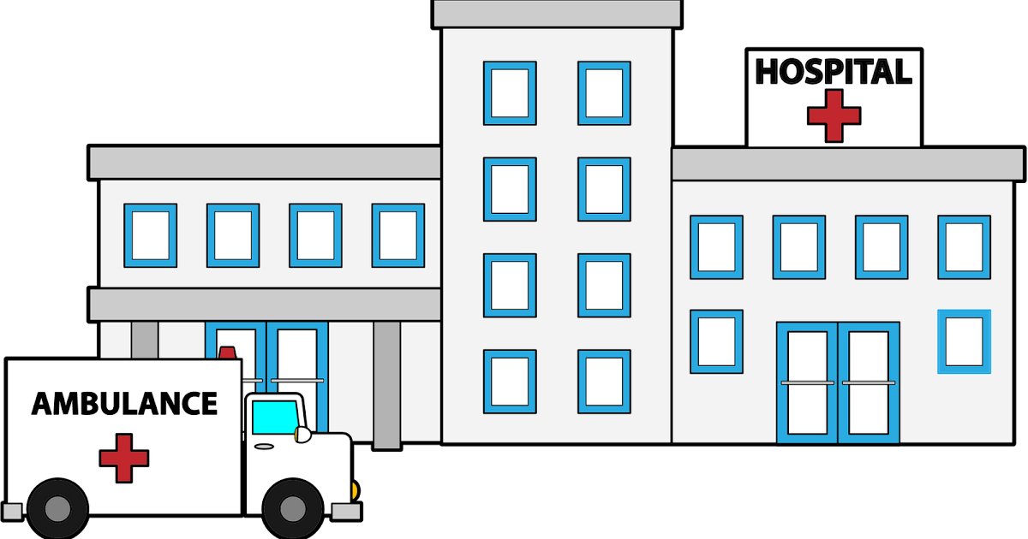

Prepared

By

KEERTHANA V

( STU60e439f7804781625569783)

Department of Computer Engineering

Ramco Institute of Technology

Anna University

November 2022

**Week 1**

**Problem Statement:**

This is a software system that incorporates various factors needed for smooth working and management of a hospital. This hospital management system allows administrator to store and manage various products and related data. This includes the beds/normal accommodation/ICU accommodation as well as patient data. In case a new patient arrives, the administrator may check for bed availability in various hospital departments and allocate it accordingly as per the patient need. The system also stores the patient data in a well defined manner. The patient details include his name, number, address and various health parameters. The software system uses ASp.net as a front end to design an interactive GUI and an Sql server to store its back end data. This back end data includes accommodation details and even related patient data for effectively managing a hospital.

**Background of the Problem:**

This software will help the company to be more efficient in registration of their patients and manage appointments, records of patients. It enables doctors and admin to view and modify appointments schedules if required. The purpose of this project is to computerize all details regarding patient details and hospital details.

**User / Customer:**

* **Admin login:** Admin has an account in the system from where he administers all doctors' account and resources.
* **Doctor login:** Doctors' can create an account into the system by registering, and can view their related information like salary, patient assigned or treated.
* **Tutor login:** All the tutors are provided with an id and password to log onto the system and can view their assigned student's details.
* **Patient information:** Admin can add or delete patient from the system. It maintains respective patient's details like the disease, kind of treatment taken, doctor consulted, tests taken, days of stay, and so on.
* **Doctor's information:** Admin can view doctors' details and can even update them regularly such as updating salary, leaves taken, consulting timings etc.
* **Bed availability:** The admin can keep a check on the beds available and allotted to patients in the hospital.
* **Resources tracking:** Admin can even maintain a track of resources being utilized in the hospitals by the doctors and patients.
* **Patient bill generation:** The system automatically calculates the patient bill by considering the number of days of stay, and bed and resources charges incurred.

**Week 2**

**Proposed Solution:**

**Software Requirements:**

* Windows 10
* Sql
* html

**Hardware Components:**

* Processor – i3
* Hard Disk – 5 GB
* Memory – 1GB RAM

**Advantages:**

* The system automates the manual procedure of managing hospital activities.
* Doctors can view their patients' treatment records and details easily.
* With the help of this system admin can easily see bed availability and immediately allot it whenever any patient arrives without manually looking for bed availability.
* It even generates an instant bill thus eliminates the need of maintaining paper records for patient stay for each day.
* The system is convenient and flexible to be used.
* It saves their time, efforts, money and resources.

**Example of Existing Solution:**

[**https://www.google.com/url?sa=i&rct=j&q=&esrc=s&source=web&cd=&cad=rja&uact=8&ved=0CAMQw7AJahcKEwiwk4KiorD7AhUAAAAAHQAAAAAQAg&url=https%3A%2F%2Fwww.webalive.com.au%2Fbest-medical-and-healthcare-websites%2F&psig=AOvVaw1Aadm_jps9wEjtqYrkkG5N&ust=1668604438665948**](https://www.google.com/url?sa=i&rct=j&q=&esrc=s&source=web&cd=&cad=rja&uact=8&ved=0CAMQw7AJahcKEwiwk4KiorD7AhUAAAAAHQAAAAAQAg&url=https%3A%2F%2Fwww.webalive.com.au%2Fbest-medical-and-healthcare-websites%2F&psig=AOvVaw1Aadm_jps9wEjtqYrkkG5N&ust=1668604438665948)

**Week 3**

**User Flow:**

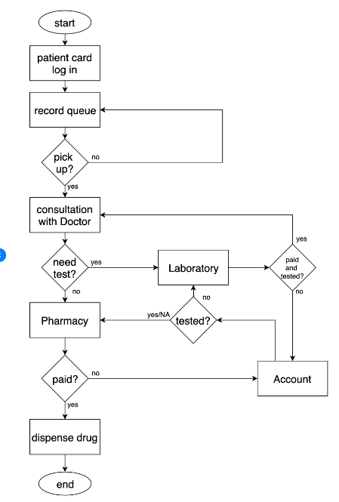

**Week 4**

**Link for the Website (Hosted on GitHub):**

**https://github.com/Keerthana20RIT/healthcare.git**